1. Code output:

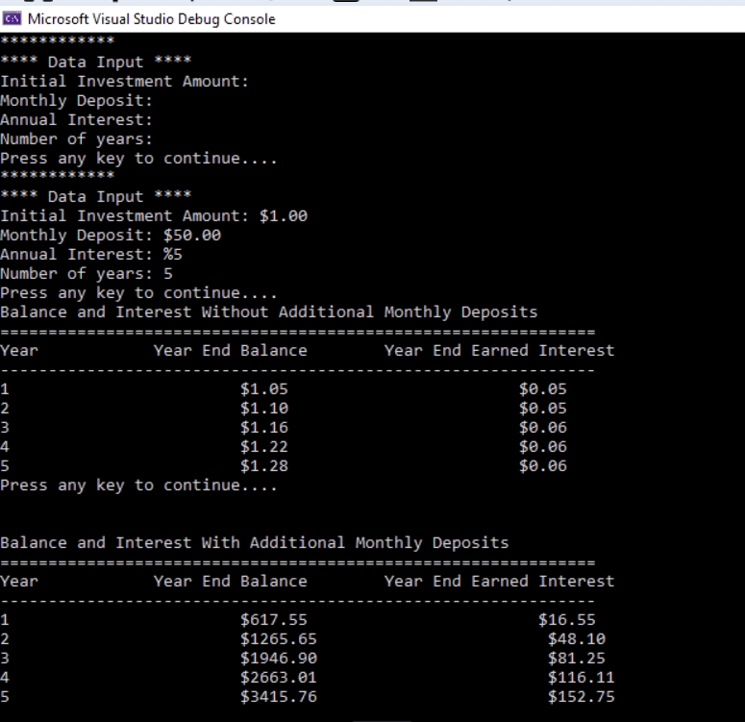

1. Code:

**MainApp.cpp**

#include <iostream>

#include <iomanip>

#include "BankClass.h"

using namespace std;

int main() {

float initInv, monDep, AnuInt, months, years;

BankClass bankclass;

bankclass.printDisplay();

cout << "Press any key to continue....";

cin.ignore();

bankclass.getValues(&initInv, &monDep, &AnuInt, &months, &years);

months = years * 12;

cout << "Press any key to continue....";

cin.ignore();

bankclass.displayTableOne(initInv, monDep, AnuInt, months, years);

cout << "Press any key to continue....";

cin.ignore();

bankclass.displayTableTwo(initInv, monDep, AnuInt, months, years);

return 0;

}

**BankClass.cpp:**

#include <iostream>

#include <iomanip>

using namespace std;

#include "BankClass.h"

BankClass::BankClass() {

// TODO Auto-generated constructor stub

}

BankClass::~BankClass() {

// TODO Auto-generated destructor stub

}

/**

*Display menu/required items

*/

void BankClass::printDisplay() {

cout << "************\n";

cout << "**** Data Input ****\n";

cout << "Initial Investment Amount: \n";

cout << "Monthly Deposit: \n";

cout << "Annual Interest: \n";

cout << "Number of years: \n";

}

/**

*Get required input from user

*/

void BankClass::getValues(float* initInv, float* monDep, float* AnuInt, float* months, float* years) {

float temp;

cout << "************\n";

cout << "**** Data Input ****\n";

cout << "Initial Investment Amount: $";

cin >> temp;

*initInv = temp;

cout << "Monthly Deposit: $";

cin >> temp;

*monDep = temp;

cout << "Annual Interest: %";

cin >> temp;

*AnuInt = temp;

cout << "Number of years: ";

cin >> temp;

*years = temp;

}

/**

*Display the first table

*/

void BankClass::displayTableOne(float initInv, float monDep, float AnuInt, float months, float years) {

float totalAm, intAmt;

totalAm = initInv;

cout << "\nBalance and Interest Without Additional Monthly Deposits\n";

cout << "==============================================================\n";

cout << "Year\t\tYear End Balance\tYear End Earned Interest\n";

cout << "--------------------------------------------------------------\n";

for (int i = 0; i < years; i++) {

intAmt = (totalAm) * ((AnuInt / 100));

totalAm = totalAm + intAmt;

//cout << (i + 1) << "\t\t$" << fixed << setprecision(2) << totalAm << "\t\t\t$" << intAmt << "\n";

cout << fixed;

cout << setprecision(2);

cout << (i + 1);

cout.width(25);

cout << "$" << totalAm;

cout.width(25);

cout << "$" << intAmt;

cout << endl;

}

}

/**

*Display the second table

*/

void BankClass::displayTableTwo(float initInv, float monDep, float AnuInt, float months, float years) {

float totalAm, intAmt, yearTotInt;

totalAm = initInv;

cout << "\n\nBalance and Interest With Additional Monthly Deposits\n";

cout << "==============================================================\n";

cout << "Year\t\tYear End Balance\tYear End Earned Interest\n";

cout << "--------------------------------------------------------------\n";

for (int i = 0; i < years; i++) {

yearTotInt = 0;

for (int j = 0; j < 12; j++) {

intAmt = (totalAm + monDep) * ((AnuInt / 100) / 12);

yearTotInt = yearTotInt + intAmt;

totalAm = totalAm + monDep + intAmt;

}

cout << fixed;

cout << setprecision(2);

cout << (i + 1);

cout.width(25);

setprecision(2);

cout << "$" << totalAm;

cout.width(25);

cout << "$" << yearTotInt;

cout << endl;

}

}

**BankClass.h:**

#ifndef BANKCLASS_H_

#define BANKCLASS_H_

class BankClass {

public:

BankClass();

virtual ~BankClass();

//print details on screen

void printDisplay();

//get user input

void getValues(float* initInv, float* monDep, float* AnuInt, float* months, float* years);

//print table one

void displayTableOne(float initInv, float monDep, float AnuInt, float months, float years);

//print second table

void displayTableTwo(float initInv, float monDep, float AnuInt, float months, float years);

};

#endif /* BANKCLASS_H_ */